1. **Qazaqstan TV**

Live Broadcast on governmental TV show “Ashyk Alan” (Open Field)

Discussion about issues that can bring Artificial Intelligence. Job loss due to AI and new boundaries in youth education.

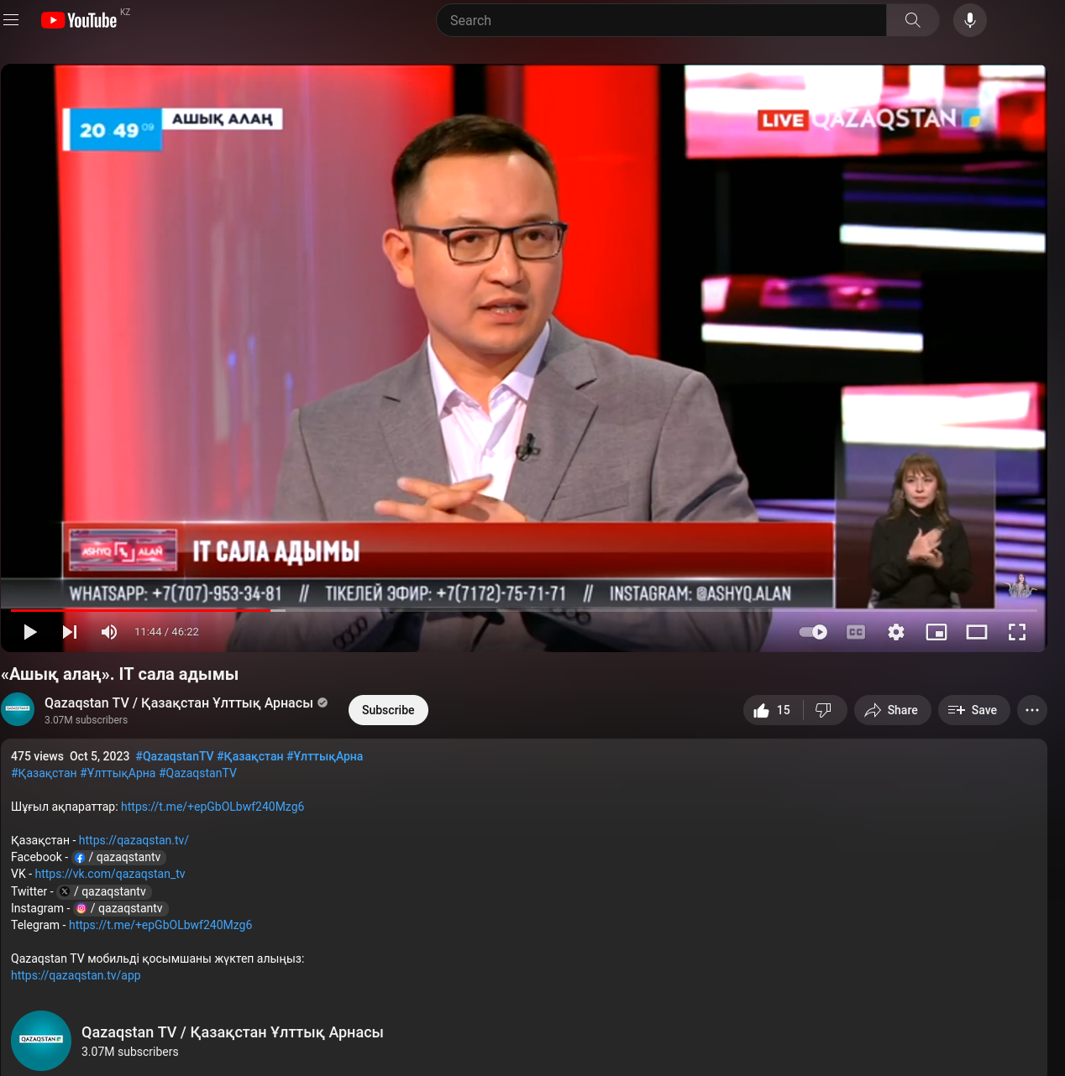

<https://www.youtube.com/watch?v=pg3KaerPFIc>

2. Forbes Kazakhstan Mention of SmartView Startup

Team of my students at SmartView Innovation use UAV and computer vision toolkit to detect defective cyanide sprinkler systems (woblers).

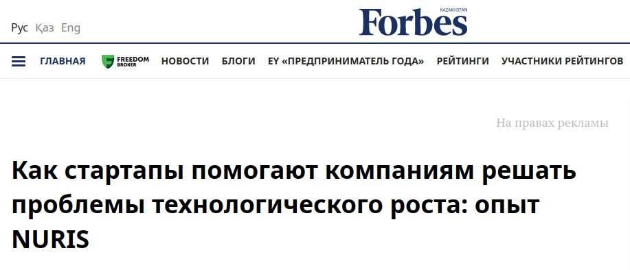

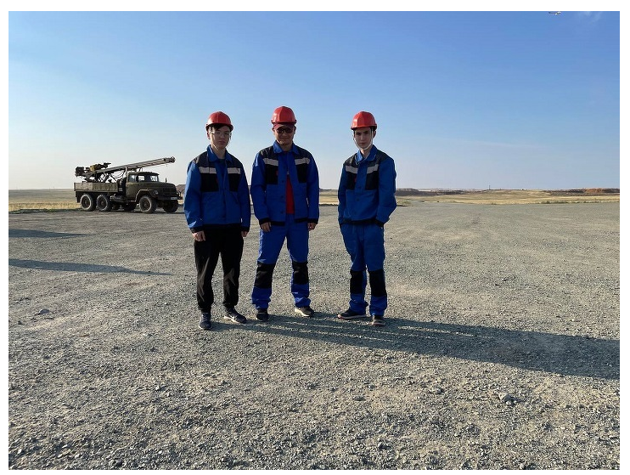

https://forbes.kz/actual/technologies/kak_startapyi_pomogayut_kompaniyam_reshat_problemyi_tehnologicheskogo_rosta_opyit_nuris/

3. Shakhmardan Yessenov Foundation - Newsfeed - Stories - Aidar Alimbayev

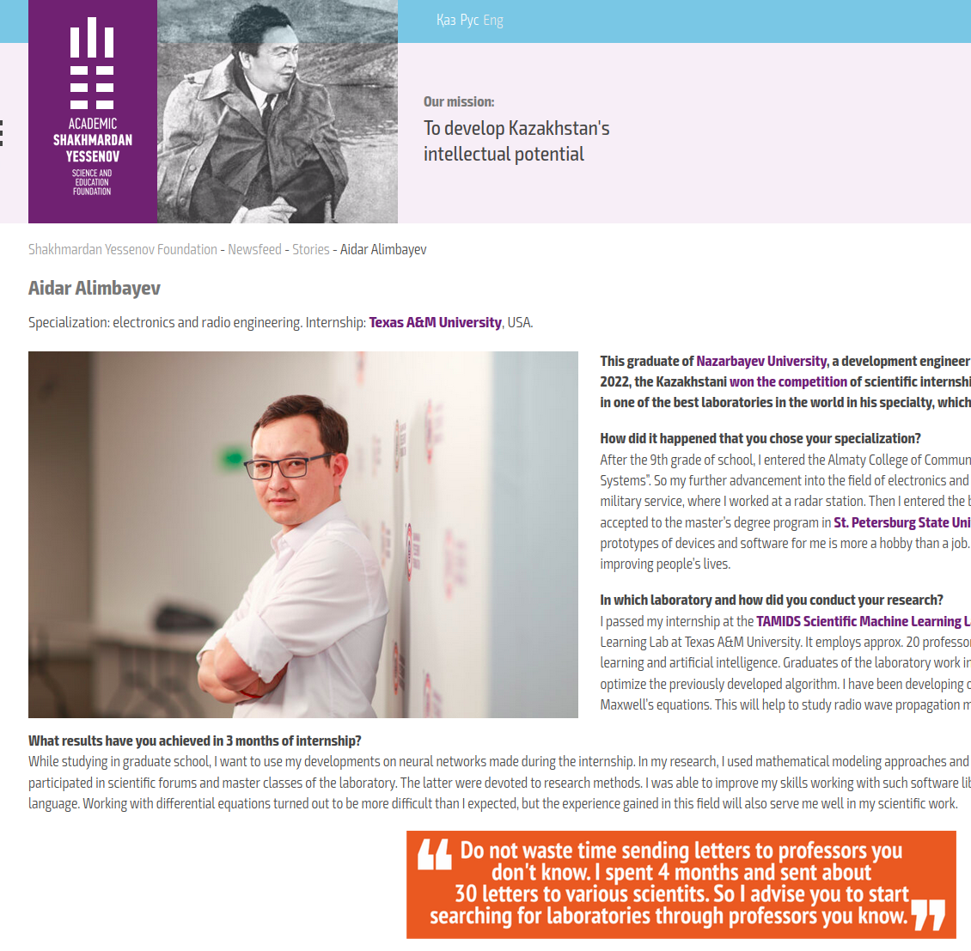  
  
  
  
<https://yessenovfoundation.org/en/eng-aidar-alimbayev/>

4. The Astana Times

Castelloli Smart Scooter Challenge - publication was about students team that I have leaded as advisor. This team won First place in Spain in electric scooter building challenge.

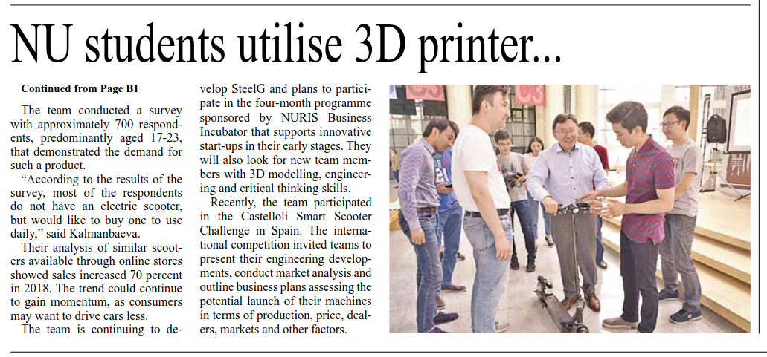

Pages B1, B5

<https://astanatimes.com/wp-content/uploads/2019/07/AT-176dd.pdf>

5. Nazarbayev UNiversity about electric scooter team

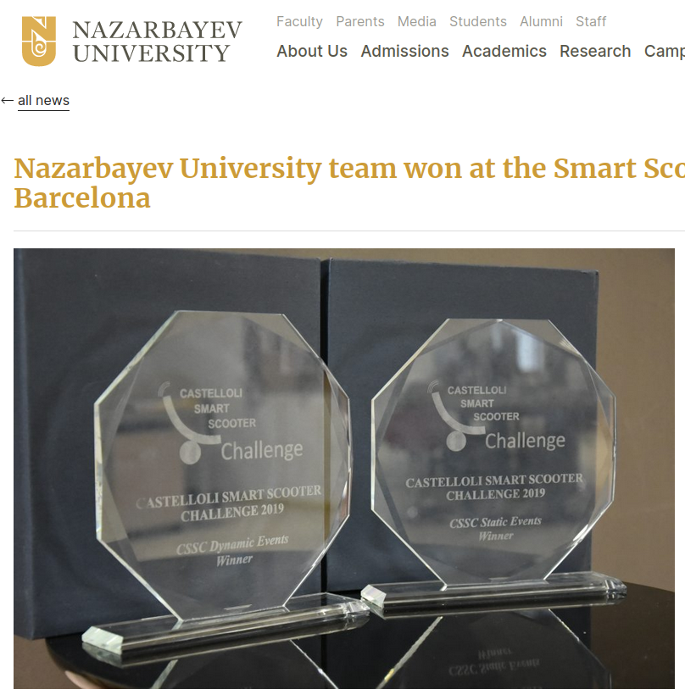

<https://nu.edu.kz/news/nazarbayev-university-team-won-at-the-smart-scooter-international-competition-in-barcelona>

5. NURIS Car

NURIS CAR was designed and manufactured in the Machine Shop prototyping center in honor of the ten-year anniversary of the University's foundation to move around the campus of Nazarbayev University.

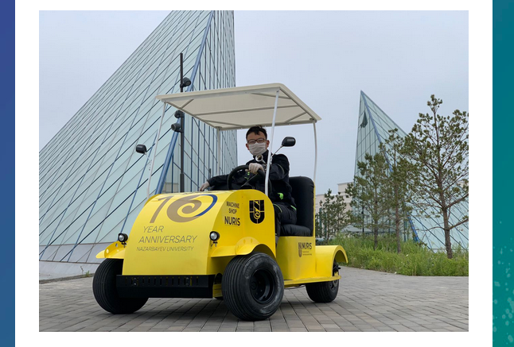

<http://digest2.nu.edu.kz/electriccar>